TASK 2 – THREAT MODEL AND SECURE CONFIGURATION

1. Introduction
- This project presents a threat model and security hardening plan for a hypothetical Student Task Manager Web Application.
- The purpose of this exercise is to identify potential security threats, assess their likelihood and impact, and recommend appropriate defensive controls.
- The analysis uses the STRIDE threat-modeling methodology to identify threats related to spoofing, tampering, repudiation, information disclosure, denial of service, and elevation of privilege.

2. Application Overview
The Student Task Manager is a small web application that allows students to manage their personal tasks.

Main functionality
Users can:
- Create an account
- Log in
- Create tasks
- View their tasks
- Edit tasks
- Delete tasks
- Receive email notifications
The application consists of:
- Student/User
- Web Browser
- Web Application
- Database
- Authentication Service
- Email Service

3. Users, Data and External Dependencies

3.1 Users

Student/User
The primary user of the application.
The student can authenticate and manage their own tasks.

Administrator
An administrator may have additional privileges for managing the application and user accounts.

3.2 Important Data/Assets
Asset | Description | Security Importance
User credentials | Username/email and password information | High
User profile | Basic user account information | Medium
Student tasks | Tasks created and managed by users | High
Session information | Information used to maintain authenticated sessions | High
Database | Stores application and user information | High
Application source code | Application logic and configuration | High
Email information | Information used for notifications | Medium
Security logs | Records of important application events | Medium

3.3 External Dependencies
The hypothetical application uses the following external dependencies:

Authentication Service
Used to authenticate users and manage login-related functionality.

Email Service
Used to send notifications to users.

Database
Stores application data such as users and tasks.

4. Trust Boundaries
A trust boundary represents a point where data moves between different levels of trust.

Trust Boundary 1 – User to Web Application
The user connects to the web application through the Internet.
Untrusted user input enters the application at this boundary.
Security considerations:
- Input validation
- HTTPS
- Authentication
- Authorization
- Rate limiting

Trust Boundary 2 – Web Application to Database
The application communicates with the database.
Sensitive application data passes through this boundary.
Security considerations:
- Parameterized queries
- Database access controls
- Least privilege
- Encryption where appropriate
- Secure credentials

Trust Boundary 3 – Web Application to External Services
The application communicates with authentication and email services.
Security considerations:
- Secure API communication
- Authentication between services
- API key protection
- Input/output validation
- Error handling

5. Threat Model Diagram

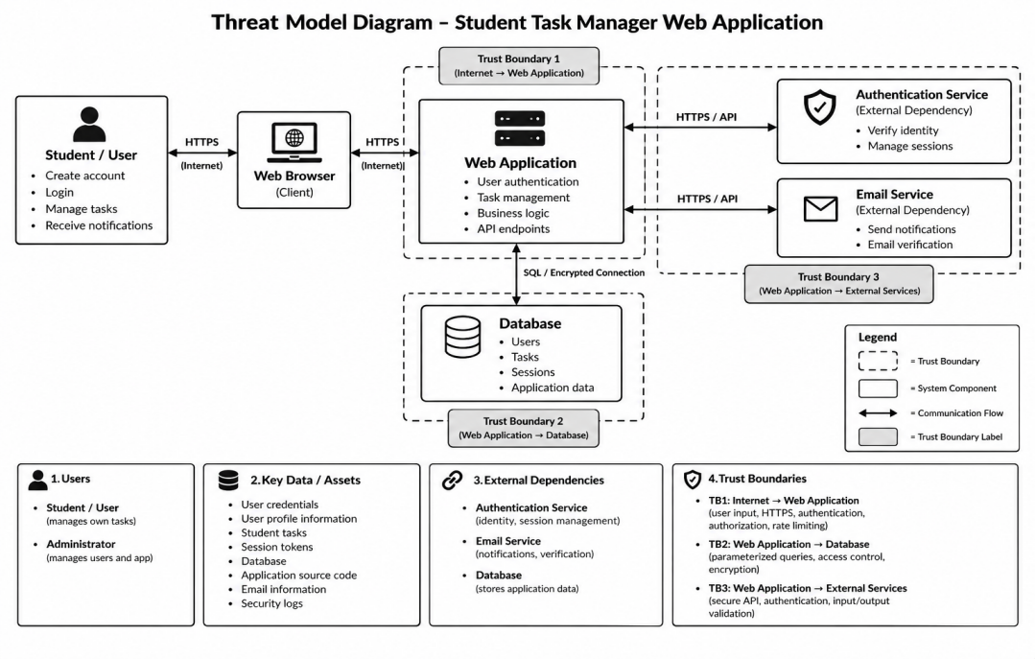

6. STRIDE Threat Analysis
The STRIDE methodology is used to identify possible threats.
STRIDE:
- S – Spoofing
- T – Tampering
- R – Repudiation
- I – Information Disclosure
- D – Denial of Service
- E – Elevation of Privilege

Threat 1 – Credential Compromise
STRIDE Category: Spoofing
An attacker may obtain a user's credentials and use them to log in as the legitimate user.
Affected asset: User account
Potential impact: Unauthorized access to the user's tasks and account information.
Recommended control:
- Secure password hashing
- Strong authentication controls
- Secure session management
- Rate limiting for login attempts
- Multi-factor authentication where appropriate

Threat 2 – Unauthorized Task Modification
STRIDE Category: Tampering
A malicious user may attempt to modify or delete another user's tasks.
Affected asset: Student task data
Potential impact: Loss or unauthorized modification of user information.
Recommended control:
- Server-side authorization
- Object-level access controls
- Verify ownership before modifying data
- Input validation

Threat 3 – Lack of Accountability
STRIDE Category: Repudiation
A user may deny performing a particular action if important security events are not recorded.
Affected asset: Security/audit records
Potential impact: Difficulty investigating suspicious activity.
Recommended control:
- Security logging
- Record important authentication and account events
- Protect logs from unauthorized modification
- Monitor suspicious activity

Threat 4 – Unauthorized Information Disclosure
STRIDE Category: Information Disclosure
An attacker may attempt to access another user's tasks or account information.
Affected asset: User data and tasks
Potential impact: Exposure of private information.
Recommended control:
- Strong authorization
- Access control checks
- Secure database queries
- HTTPS
- Avoid exposing sensitive information in error messages

Threat 5 – Denial of Service
STRIDE Category: Denial of Service
An attacker may send a large number of requests to the application and affect its availability.
Affected asset: Web application
Potential impact: Legitimate users may be unable to access the application.
Recommended control:
- Rate limiting
- Request validation
- Resource monitoring
- Appropriate traffic controls

Threat 6 – Privilege Escalation
STRIDE Category: Elevation of Privilege
A normal user may attempt to access administrator functionality.
Affected asset: Administrative functions
Potential impact: Unauthorized administrative actions.
Recommended control:
- Role-based access control
- Server-side authorization
- Least-privilege permissions
- Separate administrative functions
- Regular permission reviews

7. Risk Assessment Method
Risk is assessed using:
Risk Score = Likelihood × Impact
Both likelihood and impact are rated from 1 to 5.

Likelihood
Score | Description
1 | Very unlikely
2 | Unlikely
3 | Possible
4 | Likely
5 | Very likely

Impact
Score | Description
1 | Very low
2 | Low
3 | Moderate
4 | High
5 | Very high

For this hypothetical application, the resulting scores are used to prioritize security controls.

8. Risk Register
ID | Threat | STRIDE | Likelihood | Impact | Risk Score | Priority
T1 | Credential compromise | Spoofing | 3 | 5 | 15 | High
T2 | Unauthorized task modification | Tampering | 4 | 4 | 16 | High
T3 | Lack of security logging | Repudiation | 3 | 3 | 9 | Medium
T4 | Unauthorized data access | Information Disclosure | 3 | 5 | 15 | High
T5 | Excessive requests / service disruption | Denial of Service | 2 | 4 | 8 | Medium
T6 | Privilege escalation | Elevation of Privilege | 2 | 5 | 10 | Medium

9. Prioritized Hardening Checklist

Priority 1 – Authentication and Authorization
- Use secure password hashing.
- Implement secure login and session management.
- Verify authorization on the server for every protected action.
- Ensure users can access only their own tasks.
- Implement role-based access control.
- Apply least-privilege permissions.

Priority 2 – Data Protection
- Use HTTPS for application communication.
- Use parameterized queries/prepared statements.
- Validate input on the server.
- Prevent unauthorized database access.
- Avoid exposing sensitive information in error messages.
- Protect sensitive configuration and credentials.

Priority 3 – Monitoring and Logging
- Record important authentication events.
- Record important authorization/security events.
- Monitor suspicious activity.
- Protect security logs from unauthorized modification.
- Establish a process for reviewing security events.

Priority 4 – Availability Protection
- Implement rate limiting.
- Validate incoming requests.
- Monitor resource usage.
- Establish appropriate traffic controls.
- Maintain appropriate backups.

Priority 5 – Ongoing Security
- Regularly update application dependencies.
- Review user permissions periodically.
- Test authentication and authorization controls.
- Review application configuration.
- Conduct periodic security assessments.

Security Controls Mapping
Threat | Main Security Control
Credential compromise | Secure authentication and password hashing
Unauthorized task modification | Server-side authorization
Lack of accountability | Security logging and monitoring
Information disclosure | Access control and secure data handling
Denial of service | Rate limiting and resource monitoring
Privilege escalation | RBAC and least privilege

11. Conclusion
- This threat-modeling exercise identified potential security risks in a hypothetical Student Task Manager web application.
- The analysis considered users, assets, trust boundaries, external dependencies, and threats using the STRIDE methodology. The risks were then assessed according to likelihood and impact.
- The proposed hardening measures focus on authentication, authorization, data protection, logging, monitoring, availability, and least-privilege access.
- Implementing these controls can help reduce the identified security risks and provide a stronger security foundation for the application.

